PROMISE & PRACTICE · DEEP DIVE · SOURCE ANALYSIS
Sharecropping & Debt — A House Divided
The Arithmetic of Debt
Name: ______________________________ Period: _____ Date: ________________
WHAT I CAN DO TODAY I can read primary sources about Sharecropping & Debt — A House Divided, weigh who made each one and why, and use evidence to answer historical questions.
Directions. The injustice is right there in the numbers. Work the ledger and see how the trap closed

THE SOURCES
DATA SET · A SHARECROPPER'S YEAR (TYPICAL FIGURES) — One family's ledger
Item Amount
Value of the family's share of the cotton crop $150
Owed to landowner's store (seed, tools, food) + ~25% interest $170
Carried-over debt from the previous year $30.
Representative figures based on historical accounts. Public domain.
THE IMAGE — The cotton fields
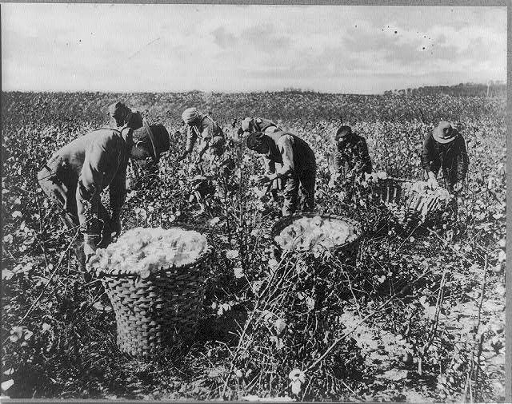
Picking cotton in the South — photograph, early 20th century, public domain (Library of Congress).

YOUR WORK
QUESTION 1 STEP 1 · RUN THE NUMBERS
Using the ledger: the family's crop share is $150. They owe $170 to the store plus $30 carried over from last year. After the crop is sold, how much does the family end up owing? Show your subtraction.
____________________________________________________________________________________________
____________________________________________________________________________________________
____________________________________________________________________________________________
QUESTION 2 STEP 2 · THE PATTERN
Based on the math, what happens when the next year begins?
☐ A. the family owns the land
☐ B. the debt disappears
☐ C. they start the new year in debt and must borrow again, repeating the cycle
☐ D. the landowner pays them extra
QUESTION 3 STEP 3 · WHY THEY COULDN'T LEAVE
A worker in debt usually could not leave to find a better job. Explain how debt — not chains — kept sharecroppers bound to the land. Why is this called “debt peonage”?
____________________________________________________________________________________________
____________________________________________________________________________________________
____________________________________________________________________________________________
QUESTION 4 STEP 4 · SLAVERY'S SHADOW
Sharecropping was not slavery — but historians say it reproduced slavery's core result. Using the numbers you worked out, explain that result in three or four sentences.
____________________________________________________________________________________________
____________________________________________________________________________________________
____________________________________________________________________________________________
____________________________________________________________________________________________
____________________________________________________________________________________________
Promise & Practice · ShadowDog Digital Studios · Unit 2

TEACHER ANSWER KEY — Sharecropping & Debt — A House Divided

QUESTION 1: Open response.
Look for a response along the lines of: “$150 − ($170 + $30) = …. The family ends the year owing $___.”
QUESTION 2: Correct — C. they start the new year in debt and must borrow again, repeating the cycle
Right. The family starts the new year already in debt, has to borrow again, and the cycle repeats — often growing deeper each year. That's the trap.
QUESTION 3: Open response.
Look for a response along the lines of: “Debt bound them because…”
QUESTION 4: Open response.
Look for a response along the lines of: “The numbers show that sharecropping kept Black families…”

